Hardware

Accelerated Graphics Port (AGP)
An interface specification developed by Intel Corporation. AGP is based on PCI, but is designed especially for the throughput demands of 3-D graphics. Rather than using the PCI bus for graphics data, AGP introduces a dedicated point-to-point channel so that the graphics controller can directly access main memory. The AGP channel is 32 bits wide and runs at 66 MHz. This translates into a total bandwidth of 266 MBps, as opposed to the PCI bandwidth of 133 MBps. AGP also supports two optional faster modes, with throughputs of 533 MBps and 1.07 GBps. In addition, AGP allows 3-D textures to be stored in main memory rather than video memory. You can differentiate a AGP card/slot from a PCI (see definition below), by looking at two things:
- The contacts on the card will be much closer together, and also appear in a staggered formation (see photo).
- The contacts will be flushed back a greater distance from the faceplate than found in PCI cards.
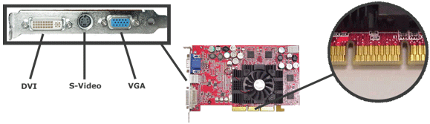

Bandwidth
Is the range within a band of wavelengths or frequencies, and represents the amount of data which can be transmitted within a fixed amount of time. Bandwidth is expressed in terms of bits per second (bps) or bytes per second. For analog devices, bandwidth is then described in terms of cycles per second, or Hertz.

Baud
Pronounced bawd, is the indicator representing the number of bits per second. A measurement of speed transmitted through your communications line. ie; a modem.

Basic Input/Output System (BIOS)
Pronounced bye-ose, is a built-in software which is typically placed in the ROM chip of your computer. On a PC, the BIOS contains the codes required to control such things such as your keyboard, disk drivers and communication ports. The BIOS also loads the operating system of your computer. There are many ways to enter a BIOS; popular keys are: Delete, F2, F8, or ESC.

Binary
Is a number system using base-2, which are expressed using combinations of two digits, 0 and 1.

Bit
A single binary digit; a 1 or a 0.


Byte
Pronounced bite; is comprised of 8 bits; is a unit of data typically holding a single character, such as a letter, digit or punctuation mark. A byte can represent 2⁸ or 256 different patterns for data.
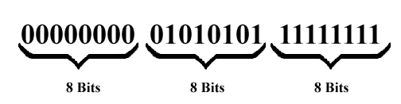

Cathode Ray Tube (CRT)
A CRT is a specialized vacuum tube in which images are produced when an electron beam strikes a phosphorescent surface. Most desktop computer displays make use of CRTs. The CRT in a computer display is similar to the "picture tube" in a television receiver.
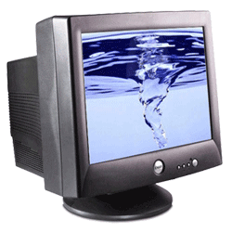

Central Processing Unit (CPU)
The CPU is the brains of the computer. Sometimes referred to simply as the processor or central processor, the CPU is where most calculations take place. In terms of computing power, the CPU is the most important element of a computer system. As of Spring 2002 processing power is doubling every 18 months. There are currently two manufacturers that own the majority of the market, Intel (Pentium & Celeron) and AMD (Athlon & Duron). There are two general flavors of processors:
- Socket - When the heatsink and the processor are completely removed from both the motherboard and each other you will observe that the processor itself is very small and very flat. The processor itself will only take up a portion of the "board" you remove. The board is there in order to separate the numerous pins you will find on the underside. The processor will usually be somewhat raised above the surface of the "board" in order to allow maximum contact with the heatsink.
- Slot - The slot form processor is being faded out, and you will not be able to find one on current x86 machines. This form of processor is much easier to install, but costs much more to manufacture. Intel felt that their market share was being threatened by lower costing AMD socket processors, and have thus stopped designing slot processors. You can recognize this processor from it's built in heatsink, and PCI-like contacts. To install this processor you simply push it down into the contacts.
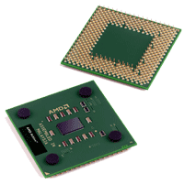 |  | 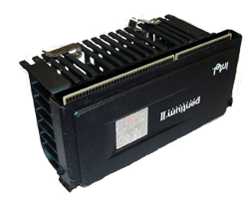

Complementary Metal Oxide Semiconductor (CMOS)
Pronounced see-moss; is used mainly as a type of semiconductor. It is the battery powered memory inside your computer which contains your PC's configuration, time and date.

Controller
A device that controls the transfer of data from a computer to a peripheral device and vice versa. For example, disk drives, display screens, keyboards, and printers all require controllers. Your computer is usually shipped with all of the necessary controllers in a single chip which would be located on your motherboard. If you find you need to install additional devices you need to ensure that the appropriate controller is designed to communicate with your expansion bus (PCI, AGP, etc).

Digital Video Interface (DVI)
DVI is a specification created by the Digital Display Working Group (DDWG) to accommodate analog and digital monitors with a single connector. There are three different DVI configurations: DVI-A, designed for analog signals, DVI-D, designed for digital signals, and DVI-I (integrated), designed for both analog and digital signals.
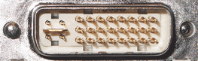 |  | 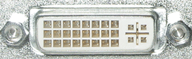

Firmware
Software stored in read-only memory (ROM) or programmable ROM (PROM) on a particular piece of hardware. Firmware is easier to change/update than hardware, but is harder than software stored on your hard drive. Firmware controls the behavior of the device as software interacts with it. You may update your firmware by downloading the necessary file from the manufactures web site (if an update is available) and "flashing" it onto the PROM.

Floppy Disk (Diskette)
A Floppy Disk is a random access, removable data storage medium that can be used with personal computers. The term usually refers to the magnetic medium housed in a rigid plastic cartridge measuring 3.5 inches square and about 2 millimeters thick. Also called a "3.5-inch diskette," it can store up to 1.44 megabytes (MB) of data. Although many personal computers today come with a 3.5-inch diskette drive pre-installed, some notebook computers and centrally-administered desktop computers omit them.
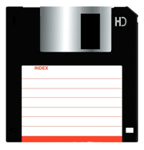

Giga (G)
Giga is a term used with computers than represents 2³⁰, or 1,073,741,824 objects. Most of the time you will see this term followed by a B (Byte), b (Bit), Bps (Bytes Per Second), or bps (Bits Per Second). For simplicity, Giga is often rounded to 1 Billion when performing quick calculations.

Hard Disk
A Hard Disk is a mass-storage device that is typically connected through your computers IDE or serial interface for internal drives, and through IEEE 1394, or USB for external drives (SCSI is an expensive option for either internal or external drives). As of Spring 2002 disk capacity is doubling every 12 months. You can currently buy new hard drives that are 300 GB for internal and 500 GB for external. Regardless of whether you buy an internal or an external drive, the drive will need some form of power and some form of communication interface for your computer. When purchasing your hard drive you will want to note a few characteristics about that drive besides the connection interface:
- Spindle Speed - Currently the fastest drive you can buy is a 10,000 RPM drive. The faster this speed is will usually correspond to a faster Data Transfer Rate. DO NOT by a 5400 RPM drive for anything but storage (MP3's collections, etc.)
- Data Transfer Rate - There are two parts to data transfer rates: 1) your computers interface maximum speed, and 2) the drives data transfer rate. If you buy a drive that has a rate faster than your computer can handle you will not receive the full benefit of your purchase.
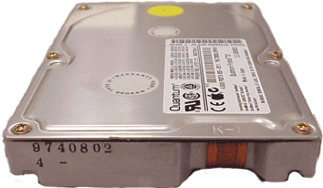

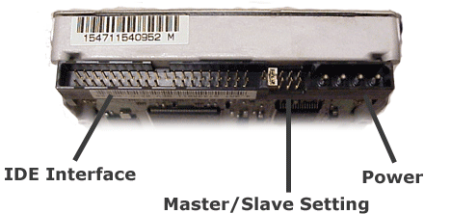

Heatsink
A heatsink is a device that is attached to a microprocessor chip to keep it from overheating by absorbing its heat and dissipating it into the air. Generally, a microprocessor's temperature should not run in excess of 50-55 degrees Celsius while under a full load. In Intel computers, the heatsink is positioned either on top of the microprocessor (in computers with a ZIF socket) or on the side of it (in later Pentiums in which the microprocessor fits into a Slot 1 interface). The heatsink may be held in place on the microprocessor by a clip. To ensure that the heatsink can absorb as much heat as possible, thermal grease is used to create a seal between the two devices.
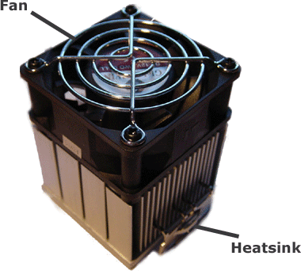

Hot Plugging
The ability to add and remove devices to a computer while the computer is running and have the operating system automatically recognize the change. Note: always be careful when removing a storage device, as you will not want to remove it during a write operation.

IEEE 1394 (Firewire)
A very fast external bus standard that supports data transfer rates of up to 400Mbps (in 1394a) and 800Mbps (in 1394b). Products supporting the 1394 standard go under different names, depending on the company. Apple, which originally developed the technology, uses the trademarked name FireWire.
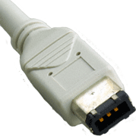 |  | 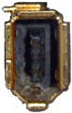

Intelligent/Integrated Drive Electronics (IDE) Interface
An IDE interface is an interface for mass storage devices, in which the controller is integrated into the disk or CD-ROM drive. A computer will have two IDE ports (IDE1, or primary IDE channel and IDE2, or secondary IDE channel), both of which will have the capacity for a master and slave devices; allowing for a total of four IDE devices in current standard computers. The market may tend to shift away from IDE towards Serial devices (a new standard that has much more bandwidth).

Jumper
In a computer, a jumper is a pair of prongs that are electrical contact points set into the computer motherboard or an adapter card. When you set a jumper, you place a plug on the prongs that completes a contact. Jumper settings tell the computer how it is configured and what operations can be performed. Computers come with jumpers preset. Instructions are sometimes provided so that the owner can reset the jumpers when new equipment is added. The latest trend, however, is Plug and Play equipment that does not require manual setting of jumpers. A group of jumpers is sometimes called a jumper block.
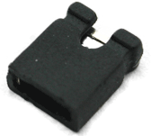

Keyboard
On most computers, a keyboard is the primary text input device. (The mouse is also a primary input device but lacks the ability to easily transmit textual information.) The keyboard also contains certain standard function keys, such as the Escape key, tab and cursor movement keys, shift and control keys, and sometimes other manufacturer-customized keys.

Kilo (K)
Kilo is a term used with computers than represents 2¹⁰, or 1,024 objects. Most of the time you will see this term followed by a B (Byte), b (Bit), Bps (Bytes Per Second), or bps (Bits Per Second). For simplicity, Kilo is often rounded to 1 Thousand when performing quick calculations.

LPT (Parallel) Port
LPT (line print terminal) is the usual designation for a parallel port connection to a printer or other device on a personal computer. Most PCs come with one or two LPT connections designated as LPT1 and LPT2. Some systems support a third, LPT3. Whatever the number, LPT1 is the usual default. You can add a parallel port for a second printer or other device by buying and adding a parallel port adapter card to your computer. An LPT port can be used for an input device such as QuickCam, a video camera used with CU-SeeMe.
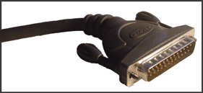 |  | 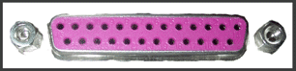

Liquid Crystal Display (LCD)
LCD (liquid crystal display) is the technology used for displays in notebook and other smaller computers. Like light-emitting diode (LED) and gas-plasma technologies, LCDs allow displays to be much thinner than cathode ray tube (CRT) technology. LCDs consume much less power than LED and gas-display displays because they work on the principle of blocking light rather than emitting it.
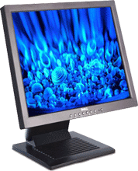

Local Bus
A data bus that connects directly, or almost directly, to the microprocessor. Although local buses can support only a few devices, they provide very fast throughput.

Mega (M)
Mega is a term used with computers than represents 2²⁰, or 1,048,576 objects. Most of the time you will see this term followed by a B (Byte), b (Bit), Bps (Bytes Per Second), or bps (Bits Per Second). For simplicity, Mega is often rounded to 1 Million when performing quick calculations.

Modem
A modem modulates outgoing digital signals from a computer or other digital device to analog signals for a conventional copper twisted pair telephone line and demodulates the incoming analog signal and converts it to a digital signal for the digital device.

Monitor
Also called a display. A device that displays text and graphics generated by a computer.

Motherboard
The main circuit board of a microcomputer. The motherboard contains the connectors for attaching additional boards. Typically, the motherboard contains the CPU, BIOS, memory, mass storage interfaces, serial and parallel ports, expansion slots, and all the controllers required to control standard peripheral devices, such as the display screen, keyboard, and disk drive; sometimes you will find that the motherboard has other integrated devices such as an audio card and video card. The motherboard is the largest circuit board in most computers and is held on by several screws.
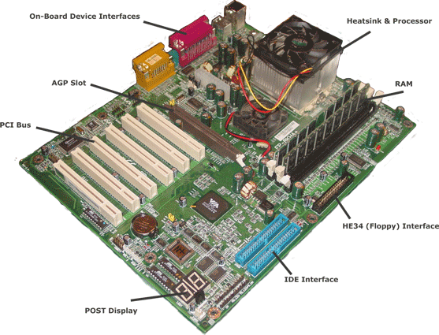

Mouse
A mouse is a small device that a computer user pushes across a desk surface in order to point to a place on a display screen and to select one or more actions to take from that position. The mouse first became a widely-used computer tool when Apple Computer made it a standard part of the Apple Macintosh. Today, the mouse is an integral part of the graphical user interface (GUI) of any personal computer. The mouse apparently got its name by being about the same size and color as a toy mouse.

Network Interface Card (NIC)
A network interface card (NIC) is a computer circuit board or card that is installed in a computer so that it can be connected to a network. Personal computers and workstations on a local area network (LAN) typically contain a network interface card specifically designed for the LAN transmission technology, such as Ethernet or token ring. Network interface cards provide a dedicated, full-time connection to a network. Most home and portable computers connect to the Internet through as-needed dial-up connection. The modem provides the connection interface to the Internet service provider.
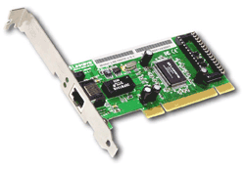

Peripheral
A peripheral (pronounced peh-RIHF-uh-ruhl, a noun truncation of peripheral device) is any computer device that is not part of the essential computer (the processor, memory, and data paths) but is situated relatively close by. A near synonym is input/output (I/O) device. Some peripherals are mounted in the same case with the main part of the computer as are the hard disk drive, CD-ROM drive, and NIC. Other peripherals are outside the computer case, such as the printer and image scanner, attached by a wired or wireless connection.

Peripheral Component Interconnect (PCI)
A local bus standard developed by Intel Corporation. Most modern PCs include a PCI bus, and only older computers will include an additional ISA expansion bus. You can differentiate a PCI card/slot from an ISA by:
- The contacts on the card/slot are much more condensed than ISA.
- The interface port is much smaller in length.
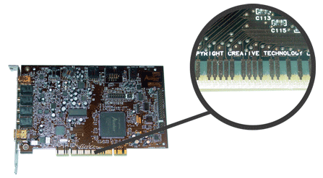

Plug-and-Play
Refers to the ability of a computer system to automatically configure expansion boards and other devices. You should be able to plug in a device and play with it, without worrying about setting DIP switches, jumpers, and other configuration elements.

Power Supply
Every computer has a power supply to change the electricity from the wall outlet into electricity the computer can use. The capacity of a power supply is measured in watts. A typical computer requires 400 watts to operate. This isn't very much, when you consider that an average hair dryer uses three and a half times as much power.
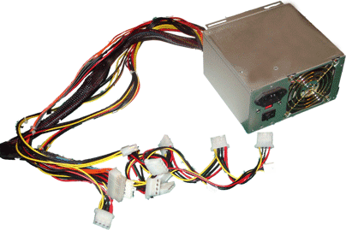

Power-On Self-Test (POST)
When power is turned on, POST (Power-On Self-Test) is the diagnostic testing sequence that a computer's basic input/output system (or "starting program") runs to determine if the computer keyboard, random access memory, disk drives, and other hardware are working correctly.

Printer
A printer is a device that accepts text and graphic output from a computer and transfers the information to paper, usually to standard size sheets of paper. Printers are sometimes sold with computers, but more frequently are purchased separately. Printers vary in size, speed, sophistication, and cost. In general, more expensive printers are used for higher-resolution color printing.

Optical Storage Device
A device that reads and/or writes from optical disks. Examples include CD-ROM, CD-RW, DVD-ROM, DVD-RAM, etc.

Random Access Memory (RAM)
A type of computer memory that can be accessed randomly; that is, any byte of memory can be accessed without touching the preceding bytes. RAM is the most common type of memory found in computers and other devices, such as printers. There are various types of RAM, including Static RAM (SRAM), Dynamic RAM (DRAM), Synchronous DRAM (SDRAM), Double Data Rate SDRAM (DDR-SDRAM), & RDRAM (Rambus DRAM).
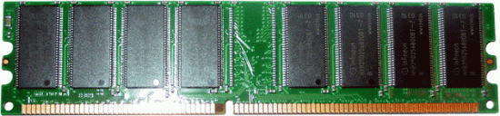

Read Only Memory (ROM)
ROM is "built-in" computer memory containing data that normally can only be read, not written to. ROM contains the programming that allows your computer to be "booted up" or regenerated each time you turn it on. Unlike a computer's random access memory (RAM), the data in ROM is not lost when the computer power is turned off. The ROM is sustained by a small long-life battery in your computer.

Redundant Array of Inexpensive Disks (RAID)
A system whereby multiple hard drives are connected together to form a single large drive for storage that provides either redundancy, performance or both.

Serial ATA (Drive Interface)
Serial ATA (Serial Advanced Technology Attachment or SATA) is a new standard for connecting hard drives into computer systems. As its name implies, SATA is based on serial signaling technology, unlike current IDE (Integrated Drive Electronics) hard drives that use parallel signaling.
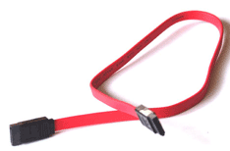
SATA has several practical advantages over the parallel signaling (also called Parallel ATA or PATA) that has been used in hard drives since the 1980s. SATA cables are more flexible, thinner, and less massive than the ribbon cables required for conventional PATA hard drives. SATA cables can be considerably longer than PATA ribbon cables, allowing the designer more latitude in the physical layout of a system. Because there are fewer conductors (only 7 in SATA as compared with 40 in PATA), crosstalk and electromagnetic interference (EMI) are less likely to be troublesome. The signal voltage is much lower as well (250 mV for SATA as compared with 5 V for PATA).

Serial (Port)
A port through which data are passed serially, i.e. , one bit at a time, and that requires only one input channel to handle a set of bits, e.g., all the bits of a byte.

Small Computer System Interface (SCSI)
SCSI is a parallel interface standard used by Apple Macintosh computers, PCs, and many UNIX systems for attaching peripheral devices to computers. Nearly all Apple Macintosh computers, excluding only the earliest Macs and the recent iMac, come with a SCSI port for attaching devices such as disk drives and printers. SCSI interfaces provide for faster data transmission rates (up to 80 megabytes per second) than standard serial and parallel ports. In addition, you can attach many devices (usually 15 on SCSI as opposed to 4 on IDE) to a single SCSI port, so that SCSI is really an I/O bus rather than simply an interface. SCSI interfaces come in several flavors, the most popular being 50 pin, or 68 pin. The 68 pin devices usually provide all of the power necessary for the device to operate properly. The key benefits/drawbacks of SCSI are:
- Very Expensive
- Difficult to Install
- Many Devices (Up to 15 per channel)
- Very Fast
- No CPU Usage
- Interface for a Variety of Devices (Scanners, CD-ROMs, Hard Drives, etc)
- Multitasking/Multi-seek

Speakers
A device that changes electrical signals into sounds loud enough to be heard.

Sound Card
A sound card (also referred to as an audio card) is a peripheral device that attaches to the ISA or PCI slot on a motherboard to enable the computer to input, process, and deliver sound.

Tera (T)
Tera is a term used with computers than represents 2⁴⁰, or 1,099,511,627,776 objects. Most of the time you will see this term followed by a B (Byte), b (Bit), Bps (Bytes Per Second), or bps (Bits Per Second). For simplicity, Tera is often rounded to 1 Trillion when performing quick calculations.

Universal Serial Bus (USB)
An external bus standard that supports data transfer rates of 12 Mbps (USB 2.0 allows for transfer speeds of up to 480 Mbps). A single USB port can be used to connect up to 127 peripheral devices, such as mice, modems, and keyboards. USB also supports Plug-and-Play installation and hot plugging.
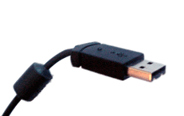

Video Card
Also called graphics adapter, display adapter, video adapter. A circuit board that enables a computer to display information on its screen.The resolution, number of colors, and refresh rate of a monitor is determined by the kind of video card used, plus the limitations of the monitor itself.

Video Graphics Array (VGA)
A term referencing a display mode used in monitors. Provides different resolutions allowing for enhanced graphics.

